# **DAV-1 Module Introduction**

### **Module Importance**

* Libraries like numpy, pandas, matplotlib & seaborn form the foundation of Python-based data analysis and visualization.
* They enable Data Analysts to efficiently manipulate, analyze, and visualize data, leading to informed decision-making.
* **Pandas:** Pandas is a powerful library for data manipulation and analysis. It provides data structures like DataFrame and Series, which are efficient for handling labeled data.
* **NumPy:** NumPy is the fundamental package for scientific computing in Python. It provides support for arrays, matrices, and mathematical functions, enabling efficient operations.
* **Matplotlib:** Matplotlib is a versatile plotting library for creating static, interactive, and publication-quality visualizations.
* **Seaborn:** Seaborn is a statistical data visualization library built on top of Matplotlib. It provides high-level functions for creating informative and attractive visuals.

**Example JDs:**

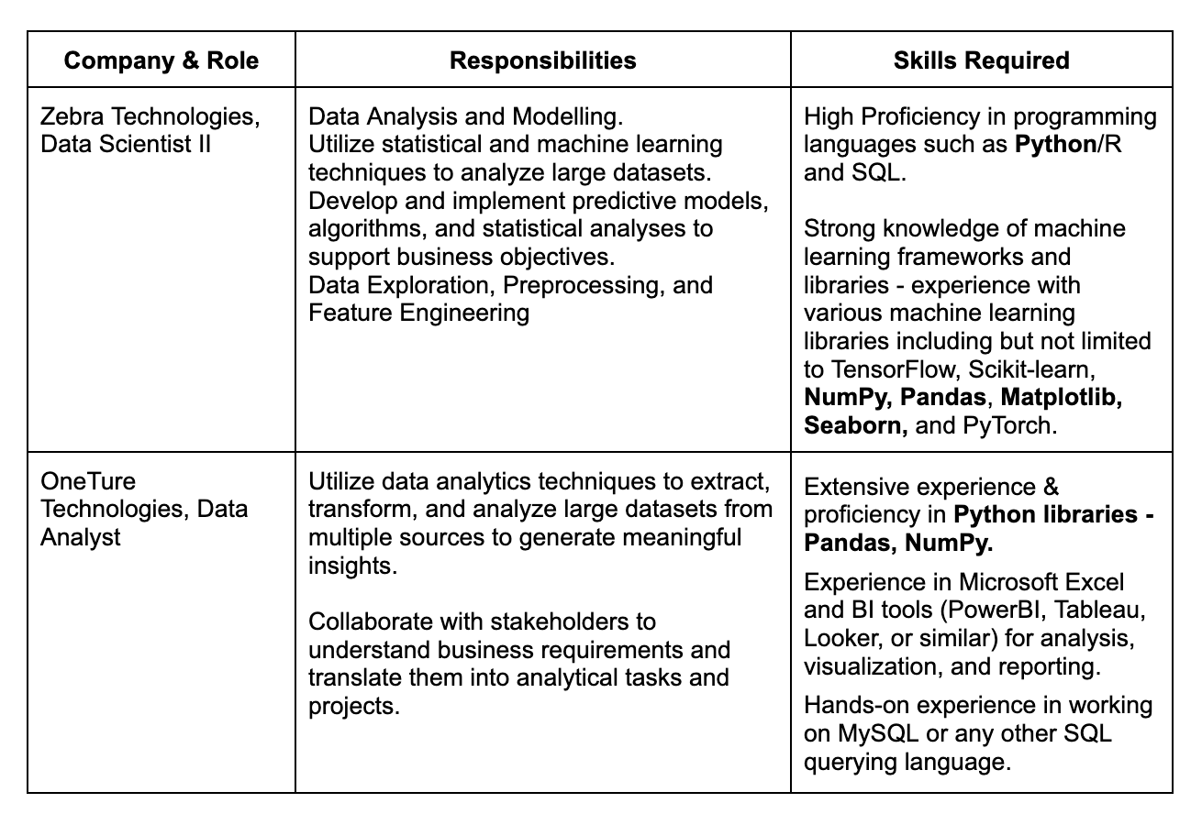

### **Module Overview**

Below, you’ll find a comprehensive breakdown of the lectures:

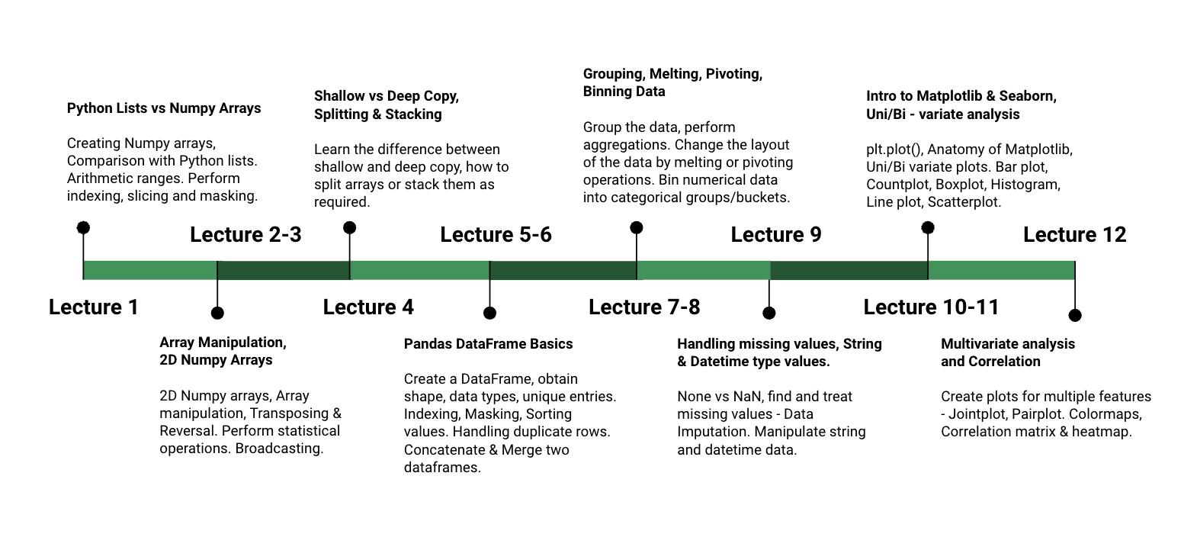

At the end of this module, there will be a **MODULE TEST** designed to evaluate and solidify your acquired skills.

### **Module Expectation**

* **Data Manipulation:** With Pandas, you can efficiently manipulate and clean datasets, including tasks like data indexing, filtering, merging, and reshaping. This skill is essential for preparing data for analysis.
* **Data Analysis:** By mastering Pandas and NumPy, you can perform advanced data analysis tasks such as descriptive statistics, data aggregation, grouping, and data transformation. These libraries provide powerful tools for extracting insights from data.
* **Data Visualization:** Matplotlib and Seaborn enable you to create a wide range of static and interactive visualizations to explore data and communicate findings effectively. You can generate various types of plots and charts, including line plots, scatter plots, bar charts, histograms, heat maps, and more.

### **Assessments & PSP**

This module covers all fundamental concepts necessary for efficient Data Analysis & Visualization across 12 comprehensive lectures.

Sharpen your skills with solving assessments:

* **5-8 assignment questions** per lecture
* **3-5 homework questions** per lecture

**Aim for a high PSP score (85+):**

* Demonstrates your expertise in advanced Python, a valuable asset for your resume and interviews.
* Not just for academic success, but it prepares you for real-world applications as well.

**Remember:**

* Seek help: Reach out to instructors or TAs for guidance.
* Track progress: Monitor PSP scores and adjust learning strategies accordingly.

### **Post-lecture Notes**

* We encourage you to regularly access **post-lecture content** via the dashboard.
* You’ll receive a comprehensive **cheat sheet** as well at the end of the module.

### **Module Test & Mock Interview**

* **At the module's end**, there will be a **module test** and **mock interview** accessible through the dashboard.
* Module test/re-test is **90 minutes** long, with all learners eligible to take both tests, which include **MCQs and Coding questions**.
* Test launch dates will be provided at the module's end, and it's crucial for all learners to participate, aiming to pass the cutoff of **70 out of 100**.
* After completing the module test, learners can book a mock interview immediately to receive feedback from Industry Experts.
* The next module will start in parallel with the module tests and mock interviews.

### **Placement Eligibility:**

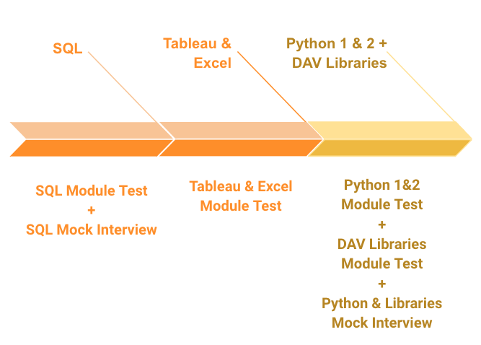

To become eligible for job placements, successful completion of all the following is required:

1. SQL module - Module Test + Mock Interview
2. Tableau & Excel module - Module Test
3. Python 1 & 2, DAV Libraries modules - Module Test + Mock Interview

Completing each of these components is crucial for your eligibility in job placements, and failing to complete either one will impede your qualification for placements.

#### **Ready to become a data analysis & visualization expert? Let's get started!**